1. What is Data Science.?
2. What is crisp model?
3. Write the different use cases for Health Care, Insurance, Banking, Energy.?
4. What are the types of analytics.?
   1. Descriptive Analytics -> What happened?
   2. Diagnostic Analytics -> Why did it happen?
   3. Predictive Analytics -> What is likely to happen?
   4. Prescriptive Analytics -> What should be done?
5. What is structured and unstructured data.?
6. What are the different data types in data science.?

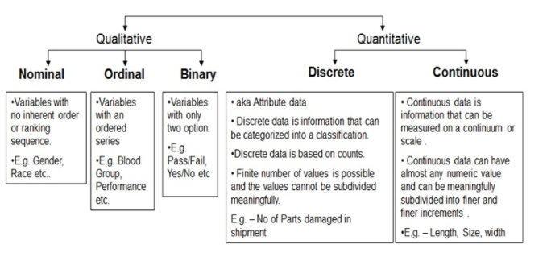

1. What is list, tuple, dictionary, set?
2. What are the different methods in list, tuple, dictionary, set.?
3. Read the data from `url` using pandas?
4. What is central tendency?
5. What is major of location.?
6. what is skewness and kurtosis
7. what is the difference between and merge and join.?

16/7

Notes Link: https://github.com/akjadon/DS_Notes/blob/master/Stats/Statistics_MyNotes.docx

1. What is central tendency.?
2. What is major of location.?
3. what is skewness and kurtosis ( home work : https://github.com/akjadon/HH/blob/master/class_demo/w0.0/827_m1_demo2_v1.0.ipynb)
4. what is the difference between and merge and join.?
5. Exercise: <https://github.com/akjadon/HH/tree/master/Python/Python_Exercise3_PandasML_Solved>
6. <https://github.com/akjadon/HH/tree/master/Python/Python_Exercise3_PandasML_Solved>

Will talk about data in

1.Descriptive steps

2. Infinential steps

1. Descriptive steps

Central tendency:

1. where we talk about major of location.

* Mean – (sum of no’s/count of no’s)
* Median – (
* mode. ( frequency ).

1. major of location
2. major spread

* standard deviation
* variance : The **variance** is a measure of variability. It is calculated by taking the average of squared deviations from the mean. **Variance** tells you the degree of spread in your data set. The more spread the data, the larger the **variance** is in relation to the mean.
  + Calc avg - > square(deviance from mean)
  + 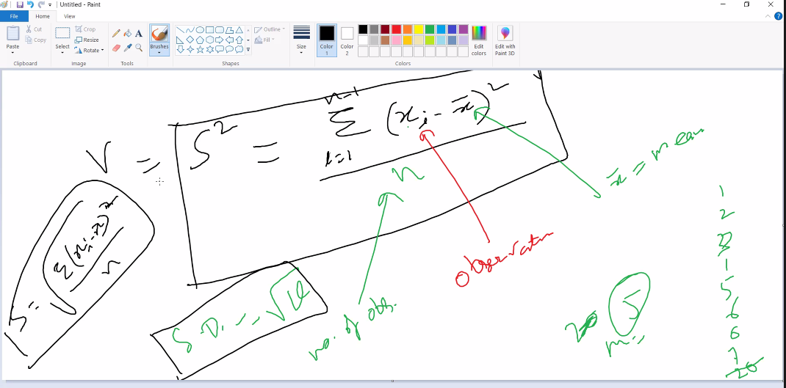
* range
  + max - min
* inter quarter range

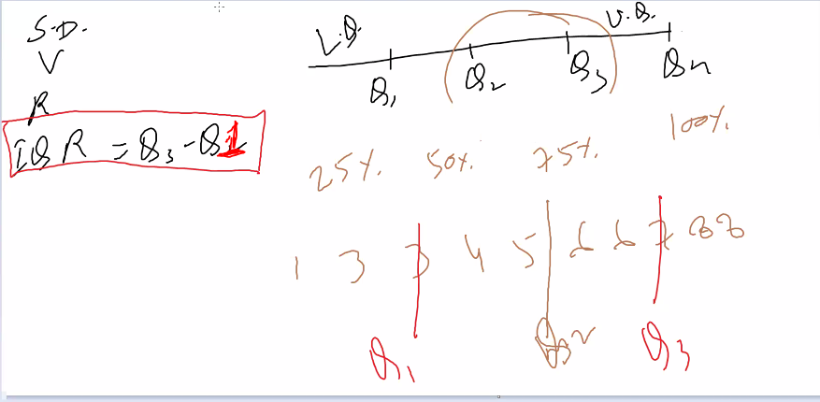

aniljadon.jadon@gmail.com